Imba Yedu
Housing Cooperative Ltd
(including Chapeltown Cohousing)

Prospectus
for
Loanstock Issue

March 2013

Imba Yedu Housing Cooperative Ltd.

Registered under the Industrial and Provident Societies Acts,
Register No. 29376 R

Registered Office:
115 Spencer Place, Leeds, LS7 4DU

Contact:
Peter Richardson (Treasurer)
pete@imbayedu.force9.co.uk
0113 262 0124

1. Why are looking for loans?
We are seeking loans to raise the capital to purchase Browning House, a large historic building set in 0.25 hectares (0.6 acres) in the heart of Chapeltown.

We believe Browning House would provide the ideal base for community living and help with our plans for future cohousing. It would be transformational for the families involved and act as a springboard for wider community development.

The house already provides sufficient space for around 6 – 8 family units (singles, couples and families with children). It has plenty of shared space both internally and externally. This space could be utilised by the families and also used as the base for developing further cohousing ideas. It also has further potential for future development if required – for example, through conversion of the small building that housed the day-nursery.

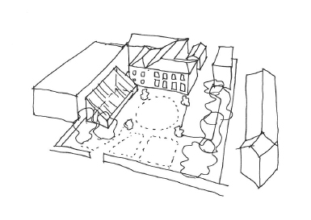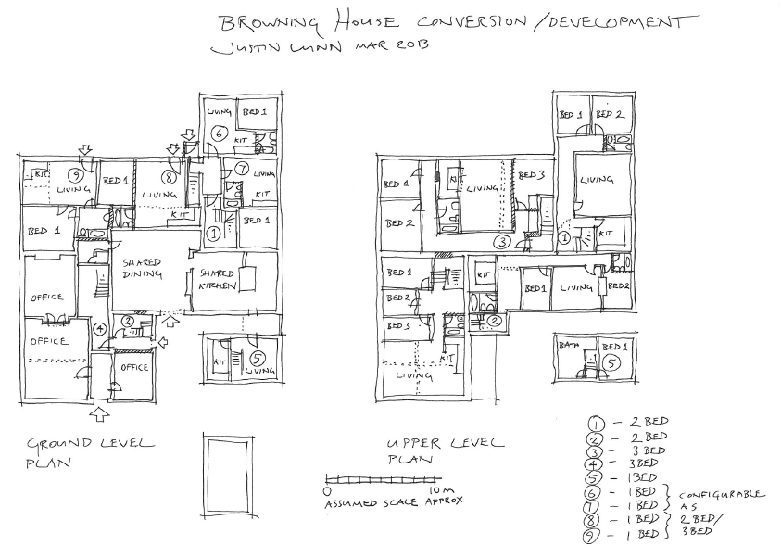

The property would therefore meet our vision by providing:

- Private apartments with shared facilities
- Potential for accessible apartments with facilities for disabled people.
- Space that was planned, owned and managed by the residents
- Shared facilities including kitchen, dining room, laundry, play areas, offices, workshop, internet access, guest rooms, gardens, growing space, potential green houses and recreational areas.
- Shared activities including cooking, eating, gardening, and running the community development project to create further cohousing
- A safe place for children to play.
- A diverse community – with a wide range of people of different ages and different backgrounds.
- Good links to the local community
- An environmentally friendly approach to living – shared facilities would reduce resources needed by each family, e.g. shared laundry facility, shared growing space, car sharing, bike workshop, communal play facilities, combined food growing areas.
- Opportunities for improving the building to incorporate better insulation and to add eco/green features. The property has a large number of south facing roofs.
- Sufficient guest accommodation to provide emergency accommodation for refugees and asylum seekers through existing links to Leeds Asylum Seekers Support Network
- Space to develop our existing food cooperative and open this up to the wider community.
- Space to expand our existing involvement in Fair Trade and the local fair trade shop
- Space to resource existing community groups and organisation we are involved with such as Tidal and Chapeltown Conservations.
- A base to continue conversations with local schools around gardening projects in Leopold Street

In order to purchase the property we are aiming to raise a total of around £400,000. Some of this will come from the sale of the cooperative’s current property. We intend to raise the rest through loanstock and a mortgage from Ecology Building Society, our current mortgage provider.

If you share our vision we invite you to purchase loanstock in ImbaYedu.

2. What is Imba Yedu Housing Cooperative Limited?
Imba Yedu is a registered housing cooperative set up in 2002 with the aim of providing, constructing, converting, improving or managing accommodation on cooperative principles. Our long-term aim is to create cooperative cohousing in the Chapeltown area of inner-city Leeds. Imba Yedu means “our house” – as we expand we may need to change the name!

Imba Yedu was started by four people with the purchase of a house on Spencer Place, Chapeltown, Leeds. Imba Yedu has continued with this single property until the present time.

Since developing the vision for Chapeltown Cohousing we have increased our membership to 6 adults and have a further 17 adults who have expressed and interest in potentially moving in to cohousing.

Modern living is often very individual and isolated, but in housing cooperative communities people know their neighbours and collaborate with them. Children benefit from more secure play-space and shared activities. Older people benefit from companionship and mutual support. And everyone benefits from the creativity and challenge of living with others.

Cooperative cohousing shows one way of living with the future in mind. It helps create community and social connection and provides a more environmentally friendly way for individuals and families to live. Cohousing can be a positive way to respond to climate change and the pressures caused by population growth.

Cooperative cohousing is designed to enable individuals to play a more active role in the community and to provide resources that can be used as a hub for community activity and community development.

3. What is Loanstock?
Loanstock is a loan in the form of an unsecured fixed term, fixed interest bond. Loanstock is non-transferable (i.e., it cannot be transferred from one person to another unless it is held jointly), and confers neither voting rights nor any control over the Cooperative. There is no schedule for regular capital repayments; rather, interest on loanstock is paid annually, and the capital is repaid in full at the end of the term. Early repayment is possible at the discretion of the Cooperative; the Cooperative can also choose to repay loanstock at any time.

Loanstock is offered by Imba Yedu for terms ranging from 3½ to 20½ years at lender-chosen interest rates ranging from 0% to 4%. However, as we are Cooperative seeking to develop affordable housing, we offer this loanstock as an opportunity for those who share our vision to help us make it a reality, rather than as an opportunity to make a financial return on an investment, and choosing a lower interest rate offers us more support.

An application form with instructions on how to purchase loanstock, and terms and conditions, may be found at the end of this prospectus. Please note that you can apply for more than one loanstock issue with different interest rates or for different repayment periods.

4. Are There Financial Risks Involved?
Yes. We are confident, based on our financial planning, that Imba Yedu’s plans are viable. However, please be aware that loanstock is treated as an unsecured loan and therefore carries an element of risk.

We are using the loanstock to purchase a property, which means that the cooperative will have substantial assets that can be sold. However, we cannot guarantee that we would be able to repay all loanstock in the event of bankruptcy.

You should also be aware that Imba Yedu is not considered to be conducting regulated activities by the Financial Services Authority, and investors therefore have no right of complaint to the Financial Ombudsman or recourse to the Financial Services Compensation Scheme.

5. Benefits of Investing in Imba Yedu

- An ethical investment - with interest if you choose to receive it
- An opportunity to be a catalyst for change in one of the most deprived areas of the country
- A chance to support an organisation that shares your values
- High accountability: you know exactly where your money has gone
- No bankers' bonuses

6. The Cooperative Advantage
Is being a Cooperative good business? Yes, according to a recent report by Cooperatives UK, which reveals the following:

- Fairness – 75% of people in the UK think Coops are fair, while only 18% think shareholder companies (PLCs) are.
- Trust – 66% think Coops can be trusted, but only 29% think PLCs can.
- Honesty – 63% think Coops are honest, compared with 15% who think PLCs are honest.
- Public good – 65% of people think Cooperatives work for the public good, compared with 12% who think PLCs do.

Furthermore, Cooperatives as a whole have consistently outperformed the rest of the economy for the last few years. Latest figures from Cooperatives UK reveal that Cooperative businesses in the UK have increased their combined turnover by some 19.5% to over £35.6 billion, despite the GDP in the UK decreasing by 1.7% in the same period.

7. Our Business Model
Imba Yedu’s business model is straightforward. We will purchase the property, convert it to appropriate living spaces and rent it out to existing and new members. Rental income will cover the ongoing cost, renovations and the repayment of loans.

We already have two families, one couple and one single person committed to moving into the property. Some of the property could be moved into immediately, other parts will need minor renovations.

We have therefore based our business model on fairly conservative estimates of just 3 rental incomes for 6 months, 5 rental incomes for the subsequent 5 months rising to 6 rental incomes by the end of the first year, seven rental incomes after 5 years and 8 rental incomes after 15 years.

In the future it may be possible to create further living spaces through more major alterations but we have not assumed any extra rental income in case this is not possible.

8. Financial Information
Full details of all calculations and our cashflow projections are freely available on request.

8.1 Initial costs

Expenditure

Purchase price 360,000
Stamp duty land tax 10,500
Legal fees 2,500
Survey fees 2,000
Mortgage fees 2,100
Other purchase costs 1,000
Planning and building regulations 5,160
Immediate alterations 10,000

Total expenditure 393,260

Income

Surplus from sale of existing property 60,000
Loanstock 80,000 at average of 2% interest
Mortgage* 280,000

Total income 410,000

We have also budgeted spending a further £16,000 on renovations within the first two years.

8.2. On-going income and expenditure

Yearly Expenditure
Voids 3,288
House insurance 3,000
Maintenance 5,000
FSA Fee 225
Council tax 4,000
Mortgage 18,243
Set aside for future loanstock repayment 10,000
Interest paid on loanstock 1,150

Total expenditure 44,906

Total rental income 46,980

This level of income provides sufficient cash flow to cover all expenses and to repay the mortgage and the loanstock. We have even budgeted for some major repairs and refurbishments.

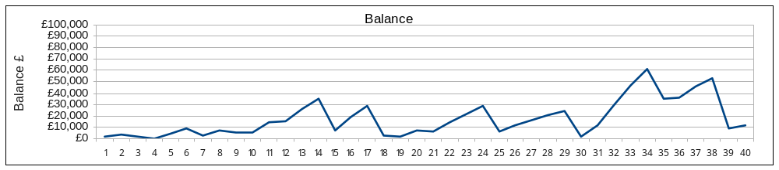

Loan Stock Application Form
Application for loan stock in Imba Yedu Housing Cooperative Limited [the Cooperative]

Registered office address: 115 Spencer Place, Leeds, LS7 4DU
Tel. 0113 262 0124 Email: pete@imbayedu.force9.co.uk
Register number: 29376 R

Please print out, complete and send both pages of this application form to: The Secretary, Imba Yedu,115 Spencer Place, Leeds, LS7 4DU

The cooperative will decide whether to accept your loanstock application within the next six months. If accepted we will ask you to transfer the funds or send a personal cheque, bank draft or building society cheque for the amount of loan stock applied for.

Thank you for your support

I, ……………………….........................................………………….. Full name(s),

of …………………………...........................…………………................………….

.........................................................................……Address, including postcode

wish to apply for loan stock in the Cooperative on the basis of the conditions below.

Telephone…………………..…… Email address…………………………………………….

Mobile…………………………………….

Amount applied for £ ……………………… (minimum £500)

Annual Interest Rate: 0% 0.5% 1% 1.5% 2% 2.5% 3% 3.5% 4%
(Please select one)

Repayment Date is:

31 December 2016
31 December 2017
31 December 2018
31 December 2020
31 December 2023
31 December 2028
31 December 2033
(Please select one of the above)

Please read the conditions and sign on the next page to accept them.

Loan Stock Conditions
1. Interest
- Interest shall be paid at the rate specified above on each full £100 of loan stock held, on the 31st December of each year, or upon the withdrawal of loan stock.
- Unless requested otherwise, interest on loan stock shall be paid from the date on which this application is received.
- In the event of the loan stock having been invested for less than the full year, interest shall be paid pro rata.
- No amount less than £1 shall be credited.

2. Repayment
- This loan stock will be repaid in full on the 31st December of the year of the specified repayment date.
- The Cooperative may accept applications for early repayment of this loan stock if it considers that there are sufficient funds available, or if a replacement investment can be arranged. A written application stating the amount requested to be repaid must be sent to the Cooperative together with the loan stock certificate. In the case of early repayment:
  - repayment will normally be made within the following periods of time after receipt of notice: up to £1000, 1 month; up to £2000, 2 months; up to £3000, 3 months; over £3000, 4 months; and
  - where part of the loan stock only is repaid, a new certificate for the outstanding amount shall be issued to the holder.
- The Cooperative may repay loan stock at any time at its discretion, including interest due up to that point.

3. Repayment on default
Repayment of this loan stock is due in full immediately if the Cooperative:
  - is in breach of these conditions;
  - is overdue on any interest payment by 21 days or more; or
  - passes a resolution for winding up, or goes into liquidation, or has an administrative receiver appointed over any of its assets, or has an administration order made against it, or an effective instrument of dissolution is made by the members of the Cooperative.

4. General
- All loan stock applications are accepted at the discretion of the Cooperative.
- These conditions shall not give the lender any rights to attend meetings or participate in any way in the management of the Cooperative other than those she/he might have as a member.
- These conditions shall not in any way be affected by the lender becoming or ceasing to be a member of the Cooperative.
- Loan stock is non-transferable (ie it cannot be sold on to another person).

I have read the above conditions and I accept them.

…………………................……….……….. (signed) …….…………………………….. (date)

…………………................……….……….. (joint applicant if applicable) ….………... (date)

How did you hear about this loan stock issue? …………………………………………………

Mayo, E. & Simon, G. 2010 Good Business? Public Perceptions of Cooperatives. Available to download at: http://www.uk.coop/goodbusiness
The UK Cooperative Economy 2012, Cooperatives UK, Manchester

